1-The electric field in a region of space has the components E_{y} = E_{z} = 0 and E_{x} = (3.80 N/(C·m))x. Point A is on the y axis at y = 3.90 m, and point B is on the x axis at x = 2.10 m. What is the potential difference (in V) V_{B} – V_{A}?

2- An infinite, nonconducting sheet has a surface charge density σ = +8.68 pC/m². (a) How much work is done by the electric field due to the sheet if a particle of charge q₀ = 3.20 × 10⁻¹⁹ C is moved from the sheet to a point P at distance d = 3.05 cm from the sheet? (b) If the electric potential V is defined to be zero on the sheet, what is V at P?

3-A spherical drop of water carrying a charge of 36 pC has a potential of 750 V at its surface (with V = 0 at infinity). (a) What is the radius of the drop? (b) If two such drops of the same charge and radius combine to form a single spherical drop, what is the potential at the surface of the new drop?

4-The figure shows a rectangular array of charged particles fixed in place, with distance a = 38.8 cm and the charges shown as integer multiples of q₁ = 4.44 pC and q₂ = 5.77 pC. With V= 0 at infinity, what is the net electric potential at the rectangle's center?
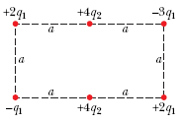

5-In the figure what is the net electric potential at point P due to the four particles if V = 0 at infinity, q = 7.61 fC, and d = 3.83 cm?
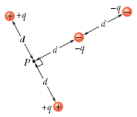

6- In the figure particles with charges q₁ = +6e and q₂ = -17e are fixed in place with a separation of d = 21.7 cm. With V = 0 at infinity, what are the finite (a) positive and (b) negative values of x at which the net electric potential on the x axis is zero?
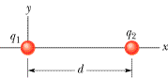

7-The figure shows a thin rod with a uniform charge density of 2.90 μC/m. Evaluate the electric potential at point P if d = D = L/4.00.

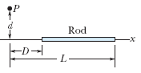

8- Two parallel-plate capacitors, 1.2 μF each, are connected in parallel to a 83 V battery. One of the capacitors is then squeezed so that its plate separation is halved. Because of the squeezing, (a) how much additional charge is transferred to the capacitors by the battery and (b) what is the increase in the total charge stored on the capacitors?

9- In the figure the battery has a potential difference of V = 10.0 V and the five capacitors each have a capacitance of 9.50 µF. What is the charge on (a) capacitor 1 and (b) capacitor 2?
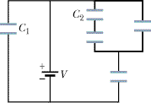

10-Plot 1 in Figure (a) gives the charge q that can be stored on capacitor 1 versus the electric potential V set up across it. The vertical scale is set by q_{s} = 28 μC, and the horizontal scale is set by V_{s} = 8.0 V. Plots 2 and 3 are similar plots for capacitors 2 and 3, respectively. Figure (b) shows a circuit with those three capacitors and a 5.2 V battery. What is the charge stored on capacitor 2 in that circuit?
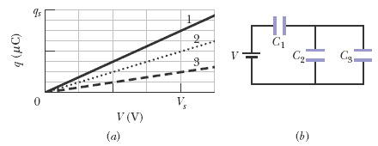

11-The figure shows a circuit section of four air-filled capacitors that is connected to a larger circuit. The graph below the section shows the electric potential V(x) as a function of position x along the lower part of the section, through capacitor 4. Similarly, the graph above the section shows the electric potential V(x) as a function of position x along the upper part of the section, through capacitors 1, 2, and 3. Capacitor 3 has a capacitance of 0.91 μF. What are the capacitances of (a) capacitor 1 and (b) capacitor 2?
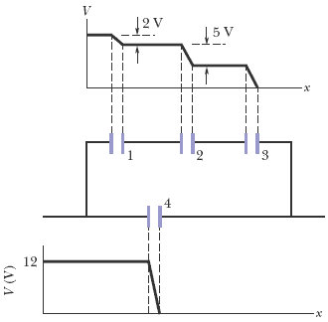

12- A charged isolated metal sphere of diameter 13 cm has a potential of 10000 V relative to V = 0 at infinity. Calculate the energy density in the electric field near the surface of the sphere.

13-The parallel plates in a capacitor, with a plate area of 8.30 cm² and an air-filled separation of 3.60 mm, are charged by a 5.70 V battery. They are then disconnected from the battery and pulled apart (without discharge) to a separation of 7.00 mm. Neglecting fringing, find (a) the potential difference between the plates, (b) the initial stored energy, (c) the final stored energy, and (d) the work required to separate the plates.

14- A charged belt, 59 cm wide, travels at 33 m/s between a source of charge and a sphere. The belt carries charge into the sphere at a rate corresponding to 95 µA. Compute the surface charge density on the belt.

15- What is the current in a wire of radius R = 1.93 mm if the magnitude of the current density is given by (a) J_{a} = J₀r/R and (b) J_{b} = J₀(1 - r/R) in which r is the radial distance and J₀ = 4.78 × 10⁴ A/m²? (c) Which function maximizes the current
density near the wire’s surface?

16- Near Earth, the density of protons in the solar wind (a stream of particles from the Sun) is 12.8 cm⁻³, and their speed is 524 km/s. (a) Find the current density of these protons. (b) If Earth's magnetic field did not deflect the protons, what total current Earth receive?

17- When 152 V is applied across a wire that is 11 m long and has a 0.26 mm radius, the magnitude of the current density is 1.9 × 10⁴ A/m². Find the resistivity of the wire.

18- A copper wire of cross-sectional area 2.00 × 10⁻⁶ m² and length 3.00 m has a current of 2.00 A uniformly distributed across that area. (a) What is the magnitude of the electric field along the wire? (b) How much electrical energy is transferred to thermal energy in 40.0 min?

19- A 180 W lightbulb is plugged into a standard 120 V outlet. (a) How much does it cost in dollars per 31-day month to leave the light turned on continuously? Assume electrical energy costs US$ 0.08/kW · h. (b) What is the resistance of the bulb? (c) What is the current in the bulb?

20- A 34 μF capacitor is connected across a programmed power supply. During the interval from t = 0 to t = 4.00 s the output voltage of the supply is given by V(t) = 6.00 + 4.00t - 2.00t² volts. At t = 0.700 s find (a) the charge on the capacitor, (b) the current into the capacitor, and (c) the power output from the power supply.

